Datasheet view-

When you upload files in bulk you are not prompted to completer the metadata for each item. You will always want complete metadata for each file. To efficiently add metadata after uploading a document, use datasheet mode on the library tab.

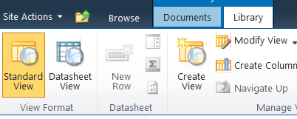

To switch back to normal view click Standard view